**ATTENDANCE TRACKING SYSTEM**

**A PROJECT REPORT**

**Submitted by**

**B.Ajith(13C07)**

**R.Ambika(13C10)**

**R.Beema Thangarani(13C21)**

***in partial fulfillment for the award of the degree***

***of***

##### BACHELOR OF ENGINEERING

*In*

**COMPUTER SCIENCE AND ENGINEERING**

**THIAGARAJAR COLLEGE OF ENGINEERING, MADURAI – 15**

(A Government Aided ISO 9001: 2008 Certified Autonomous Institution Affiliated to Anna University)



ANNA UNIVERSITY: CHENNAI 600 025

NOVEMBER 2016

**THIAGARAJAR COLLEGE OF ENGINEERING MADURAI-15**

(A Government Aided ISO 9001: 2008 Certified Autonomous Institution Affiliated to Anna University)



**BONAFIDE CERTIFICATE**

Certified that this project report **“Attendance Tracking System**” is the bonafide work of **“B.Ajith(13C07), R.Ambika(13C10), R.Beema Thangarani(13C21)** ”who carried out the project work under my supervision during the Academic Year 2016-2017

**SIGNATURE SIGNATURE**

Dr.S.Mercy Shalinie, M.E., Ph.D., Mr.N.Shivakumar, M.E., Ph.D.,

**HEAD OF THE DEPARTMENT SUPERVISOR &ASSISTANT PROFESSOR**

COMPUTER SCIENCE AND ENGINEERING COMPUTER SCIENCE AND ENGINEERING

THIAGARAJAR COLLEGE OF ENGG. THIAGARAJAR COLLEGE OF ENGG.

MADURAI – 625 015 MADURAI – 625 015

Submitted for the VIVA VOCE Examination held at Thiagarajar College of

Engineering on ………………

**INTERNAL EXAMINER EXTERNAL EXAMINER**

**Acknowledgement**

I wish to express my deep sense of gratitude to **Dr.V.Abhai Kumar,** Principal of Thiagarajar College of Engineering for his support and encouragement throughout this project work.

I wish to express my sincere thanks to **Dr.S.Mercy Shalinie**, Head of the Department of Computer Science and Engineering for her support and ardent guidance.

I owe my special thanks and gratitude to **Mr.N.Shivakumar**, Assistant Professor, Department of Computer Science and Engineering for his guidance and support throughout our project.

I am also indebted to all the teaching and non-teaching staff members of our college for helping us directly or indirectly by all means throughout the course of our study and project work.

I extremely thank my parents, family members and friends for their moral support and encouragement for my project.

##### Contents

##### 

##### 1. Introduction

##### 1.1. Attendance Tracking System 1

##### 1.1.1. Characteristics 1

##### 1.1.2. Software Architecture 1

##### 1.1.3. Hardware Architecture 2

##### 1.2. Android Environment 2

##### 1.2.1. Characteristics 3

##### 1.2.2. Services provided by Android 4

##### 2. Literature Survey

##### 2.1. Android based attendance tracking system 6

##### 2.2. Materials and Methods 6

##### 2.3. Development process 7

##### 2.4 Testing process 7

##### 2.5 Debugging 8

**3. Problem Definition and Background**

3.1. Existing Approach 9

3.2. Problem Statement 9

##### 4. Requirements and Specifications

##### 4.1. Hardware specifications 11

##### 4.2. Software Specifications 11

##### 5. Control Flow Graph 12

##### 

##### 6. Proposed Approach

6.1. System Overview 13

6.2. Phases of workflow 13

6.2.1. User authentication 13

6.2.2. Report Generation 14

##### 7. Implementation

##### 7.1. Authentication Module 16

7.1.1 Registration Module 17

7.1.2 Login Module 17

##### 7.2. Staff Module 17 7.2.1. Create Attendance Module 18

7.2.2. Take attendance module 18

7.2.3 Update Attendance module 19

7.2.4 View attendance module 19

##### 7.3 Log Module 19

##### 7.3.1 Individual Log 19

##### 7.3.2 Subject Log 20

##### 7.4 Back End 20

##### 8. Experiments and Results 22

##### 9. Conclusion and Future work 36

##### 10. References 37

**Abstract**

An Education system in India has become so advanced in last decade due to the development of the technology. Smart class, video conferencing are some of the examples of modern trends in educational system. These applications help the institute to move forward quickly, fulfill their vision and accomplish their goals, E-way. Managing the attendance of the students during lectures is a difficult task and it becomes more difficult during the report generation phase. This is because the process of marking attendance and maintaining the data is not fully automated and manual computation produces errors and also wastes a lot of time. The core idea of research project is to implement an android based application for attendance tracking system for advancement of institution and educational system. This system helps teacher to take attendance through smart phones and keep record of students for their progressive assessment. This System allows teachers to take attendance, edit attendance, view student’s bunks. In almost every institution and organization, attendance monitoring is a very important process. We have seen over the years that the process of manual attendance has been carried out across almost all educational institutions. The process is not only time consuming but also sometimes inefficient resulting in the false marking of attendance. Today, we need not maintain pen and paper based attendance registers. Following this thought, we have proposed an attendance monitoring system based on the concept of web services which is implemented as an Android mobile application that communicates with the database residing on a remote server. The mobile application would require connecting to the database using either GPRS or Wi-Fi technology.

**List of Figures**

Figure 5.1 Block Diagram

Figure 8.1 Launching attendance tracker Application

Figure 8.2 Creating Login Page

Figure 8.3 Creating registration page

Figure 8.4 New user registration

Figure 8.5 Successful registration

Figure 8.6 Signing in page

Figure 8.7 Home page

Figure 8.8 Attendance activities

Figure 8.9 Creating attendance

Figure 8.10 Entering subject details

Figure 8.11 Creating members

Figure 8.12 Entering details of members

Figure 8.13 Take attendance page

Figure 8.14 Attendance list

**List of Abbreviations**

|  |  |
| --- | --- |
| GPRS | General Packet Radio Service |
| IPC | Inter Process Communication |
| SMS | Short Message Service |
| MMS | Multimedia Messaging Service |
| GPS | Global Positioning System |
| C2DM | Cloud 2 Device Messaging |
| API | Application Program Interface |
| ADT | Abstract Data Type |
| JRE | Java Runtime Environment |
| JDK | Java Development Kit |
| GUI | Graphic User Interface |
| ASP | Active Server Pages |
| PHP | Hypertext Preprocessor |
| SQL | Structured Query Language |

**Chapter 1**

**INTRODUCTION**

* 1. **Attendance Tracking System**

**1.1.1. Characteristics**

The Attendance Monitoring System being a client-server approach, and follows a specific hardware and software architecture. The main challenge here is integrating both the hardware and software components to work together. The proposed system is user friendly because the retrieval and storing of data is fast and data is maintained efficiently. Moreover the graphical user interface is provided in the proposed system, which provides user to deal with the system very easily. This system requires very less paper work. All the data is feted into the computer immediately and reports can be generated through computers. Moreover work becomes very easy because there is no need to keep data on papers.

**1.1.2. Software Architecture:**

* **The database** consists of a number of tables, which stores records implemented in phpmyadmin- MySQL. MySQL is easy, fast and efficient and can store a large number of records and requires a little configuration.
* **The application program** is developed with Android programming language using Eclipse framework. The application program provides user interface to both the faculty members as well as the students. Programming in Android is simple, user friendly and android offers an excellent data connectivity.
* **The server** is deployed on the personal computer using apache-Tomcat7. Tomcat7 is free, robust and easy to deploy.

**1.1.3 Hardware Architecture:**

The basic requirement of the attendance tracking system is an android device, which will run the application, with the help of which the student’s will mark their attendance. The other requirement is a personal computer on the server side, which will store the database.

**1.2 Android Environment**

Android is basically an operating system for smart phones that is based on a modified version of Linux. It was originally developed by a startup of the same name, Android. Now the Android is a market-mover. Now is an exciting time for mobile developers. Mobile phones have never been more popular, and powerful smart phones are now a regular choice for consumers. Stylish and versatile phones packing hardware features like GPS, accelerometers, and touch screens are an enticing platform upon which to create innovative mobile applications. Android hardware will be designed to tempt consumers, but the real win is for developers. Android developers are free to write applications that take full advantage of increasingly powerful mobile hardware. As a result, developer interest in Android devices has made their 2008 release a hugely anticipated mobile technology event.

**1.2.1. Characteristics**

* SMS and MMS are available forms of messaging, including threaded text messaging and Android Cloud To Device Messaging and now enhanced version of C2DM, Android Google Cloud Messaging is also a part of Android Push Messaging services.
* Android supports capturing a screenshot by pressing the power and home-screen buttons at the same time. Prior to Android 4.0, the only methods of capturing a screenshot were through manufacturer and third-party customizations (apps), or otherwise by using a PC connection. These alternative methods are still available with the latest Android.
* Multitasking of applications, with unique handling of memory allocation, is available.
* Android supports multiple languages.

**1.2.2. Services provided by Android**

A service is an application component that can perform long-running operations in the background and it does not provide a user interface. Another application component can start a service and it continues to run in the background even if the user switches to another application. Additionally, a component can bind to a service to interact with it and even perform IPC.

1. ***Scheduled*:** A service is scheduledwhen an API such as the Job Scheduler, introduced in Android 5.0 (API level 21), launches the service. You can use the job scheduler by registering jobs and specifying their requirements for network and timing. The system then gracefully schedules the jobs for execution at the appropriate times. The Job scheduler provides many methods to define service-execution conditions.
2. ***Started*:** A service is started when an application component (such as an activity) calls startService(). After it's started, a service can run in the background indefinitely, even if the component that started it is destroyed. Usually, a started service performs a single operation and does not return a result to the caller. For example, it can download or upload a file over the network. When the operation is complete, the service should stop itself.
3. ***Bound***: A service is bound when an application component binds to it by calling bindService(). A bound service offers a client-server interface that allows components to interact with the service, send requests, receive results, and even do so across processes with IPC. A bound service runs only as long as another application component is bound to it. Multiple components can bind to the service at once, but when all of them unbind, the service is destroyed.

**Chapter 2**

**Literature Survey**

**2.1. Android Based attendance tracking system**

According to Dobson, tracking attendance can be a time-consuming and tedious chore. Typically, the professor takes attendance manually by requesting that every student state "here" when his or her name is called, or by scanning the classroom to figure out which students are there. The professor then records the data, and it is transmitted to the school organization, frequently by hand. So an android based attendance tracking system was proposed which allows staffs to enter the student attendance in to the server in an offline mode and the data is updated in the database once the server is connected and changes to online mode.

**2.2. Materials and methods**

In the development of the proposed application, the researchers used the Incremental Development Model in order to have a high quality android application project. Incremental development is a fundamental part of agile approaches which interleaves the activities of specification, development, and validation. The system was developed as a series of versions (increments), with each version adding functionality to the previous version. This model is based on the idea of developing an initial implementation, exposing this to user comment and evolving it through several versions until an adequate system has been developed. Specification, development, and validation activities are interleaved rather than separate, with rapid feedback across activities

**2.3. Development process**

In developing the system the researchers used Eclipse ADT Bundle for the development of the android application for the students and instructors and SQL Lite database as its storage of data. The researchers also used PHP for the development of the website that will be used by the students and instructors in terms of viewing of attendance records. These programming tools were used by the researchers because they are suitable to the development of the project.

**2.4. Testing process**

The researchers tested the project for errors and conflicts. System’s component was tested, and the whole system will run in order to find errors and then correct by debugging. There are several tests that are to be performed to acquire the desire level of confidence. This process started from unit testing, each module as which the researchers shall be tested. The researchers shall execute system testing. The last one will be the user acceptance testing which will include the evaluation process of the system that will be introduced to the faculty members and the instructors.

**2.5. Debugging process**

The researchers of the system checked the consistency of data between the android phones local database and the data that has been uploaded to the web server. Maintaining the consistency takes a lot of time for the development process. Errors come up but the researchers successfully cope with this problem.

**Chapter 3**

**Problem Definition and Background**

**3.1. Existing Approach**

In the present system all work is done on paper. The whole session attendance is stored in register and at the end of the session the reports are generated. We are not interested in generating report in the middle of the session or as per the requirement because it takes more time in calculation. At the end of the session, the students who don’t have 75% attendance get a notice.

**3.2. Problem Statement**

The proposed system is user friendly because the retrieval and storing of data is fast and data is maintained efficiently. Moreover the graphical user interface is provided in the proposed system, which provides user to deal with the system very easily. Reports can be easily generated in the proposed system so user can generate the report as per the requirement (monthly) or in the middle of the session. User can give the notice to the students so he/she become regular. The proposed system requires very less paper work. All the data is feted into the computer immediately and reports can be generated through computers. Moreover work becomes very easy because there is no need to keep data on papers. Computer operator control will be there so no chance of errors. Moreover storing and retrieving of information is easy. So work can be done speedily and in time

**Chapter 4**

**Requirements Analysis and specification**

**4.1. Hardware specifications**

* Personal desktop/Laptop - Central server with processing engine.
* The minimum memory space required is 1 GB.
* Smartphone offers more advanced computing ability and connectivity.

**4.2. Software Specifications**

Solution is developed using below technology and platforms

* Application Development – Android.
* Web Application Development – c# and ASP.Net.
* Database management – SQL Server 2012.
* Android Application Development – Microsoft Visual Studio 2005 Express Edition

**Chapter 5**

**Control Flow Graph**

Figure 5.1 Block Diagram

**Chapter 6**

**Proposed Approach**

**6.1. System Overview**

The proposed system provides solution to lecture attendance problems through the use of attendance tracking system that is interfaced to the server. Teacher will have to install the respective APK files developed for them on their android devices.

The teacher, on his/her device, fills the details. The faculty members are assigned unique faculty id. They have to enter their details and all the data is recorded in the database. After this, the teacher activates the application that is on the server and only when the application is active he/she can mark the attendance by one click. The teacher can then generate reports by a single click. The teacher will also have the access to the list of students attending the lecture and can even modify the list if required.

**6.2 Phases of workflow**

**6.2.1. User authentication**:

It is one of the major factor in attendance tracking system. Every user is authenticated based on his/her unique user identification number. This unique identification number is the number present on the ID cards of the faculty members and the students. The faculty members register themselves by signing in into the system. All their personal details are recorded during this process. After signing in, they again have to log into the system. This is done in order to ensure that only valid users access the system. A flag is set to a default value of false in the system. This flag can be altered only by the teachers and only when the flag is true, the teachers can mark their attendance. During the marking phase, the teacher of the concerned subject activates the application by triggering it from his/her device and in turn changing the value of the flag to true. Now they can mark the attendance for that particular lecture by a single click. The teacher then deactivates the app after sometime (usually after a minute) by again changing the value to false. The teacher is given facility to generate reports as soon as the students are done marking their attendance. The teacher can mark the attendance of a particular student if at all any student cannot mark the attendance due to some technical issues. Similarly, the teacher can delete the attendance of the students.

**6.2.2. Report Generation**

The next phase here is report generation. The code for generating reports is written using JSP. Only the admin, the concerned staff or faculty member is given the authority to access thispage. He/she can search for a particular student in the database and can generate reports monthly or weekly. Also, periodic SMS is sent to the student’s parents by the admin. This feature is enabled by connecting the system to an SMS gateway. After taking the attendance, they will have to set the value of flag to false. Teachers tab will be connected to the Local Server. At a particular time during the lecture, the teacher will trigger a request to start the application through his/her tab. The request here is made to the local server. This request is then forwarded to the Central Data Center and the attendance tracking application is activated. Once the application gets activated, the teachers can access the application. They can mark their attendance with the help of a single click. Thus their attendance for that lecture will be marked. This data is then sent to the CENTRAL DATA CENTER, where records are maintained [4].

**Chapter 7**

**Implementation**

Implementation is the stage of the project when the theoretical design is turned out into a working system. Thus it can be considered to be the most critical stage in achieving a successful new system and in giving the user, confidence that the new system will work and be effective.

The implementation stage involves careful planning, investigation of the existing system and its constraints on implementation, designing of methods to achieve changeover and evaluation of changeover methods.

This project will be the platform independent, i.e; project will be run on any operating system. Because any one can be access the project and upload it of their use.

Attendance Tracker is a Bunk Lord app which is designed especially for students to keep track of their attendance level and get notified when attendance drops down. It is having two modules. They are

**7.1. Authentication Module**

The purpose of Authentication module shown in Figure 3 is to provide security. It is the entry module of application. Each user enters his/her username and password to enter into application. If username and password is matched, application gets started. [1]

**7.1.1 Registration Module**

New Users can create an account with their unique email ids and a password is allocated for securing their account. The details for successful registration are Username, first name, last name, password, confirm password and email id. The details are evaluated on clicking register button and stored in registration database.

**7.1.2 Login Module**

The Registered Users can login to their accounts by entering their email id and password. If the email id and password is same as that stored in database, there will be successful login of the users. When the username is not available in database or the password entered is incorrect, there will be a prompt saying “Username or Password is Incorrect”. Every user can create attendance, take attendance and view attendance.

**7.2. Staff Module**

The main purpose of the staff module is to provide security. This module is specially designed for staffs, which use mobile device to take attendance.

**7.2.1. Create Attendance Module**

The access of this module is controlled by Admin. The purpose of this module is to enter student details such as class, subject details along with the student name. All the details entered by the admin will be stored in a database. For each class and its subject a table is created where all the details of the students are stored. All the individual tables will be having a reference that gets stored in Subject class table. Using which the appropriate table that has the details of the students can be fetched and attendance can be taken for the respective subjects.

**7.2.2. Take Attendance Module**

The user will be provided complete access of this module. He can take attendance for the class by entering the details of the subject and class so that the appropriate table will be fetched with the reference created from the main table Student class. The attendance can be marked for the class after checking the physical presence of the student and it will be updated in the respective databases. The attendance will be stored along with the date and time details that are taken automatically from the device and it will be updated in the database.

**7.2.3. Update Attendance Module**

The purpose of this module is to increase the ease of access for the user. He can update the attendance he had already entered. He can make changes to the data he entered already. Like if someone comes late to the class and staff has failed to mark his presence has he had already marked attendance for the session he can change the details entered previously with the help of this module. All the changes made to the data i.e. the attendance details will be replicated in their respective tables.

**7.2.4. View Attendance Module**

This module is meant for the user. Given the details of the Subject, Class and Date the attendance details will be fetched from theappropriate table that is stored in the database and displayed on the screen of the device used.

**7.3. Log Module**

This module is for the User to check the data stored the database. The function of this module is to view the log record of the details stored in the database. He can view the individual log records as well as subject’s log record.

**7.3.1 Individual Log**

Given the students name and class along with the subject details the attendance percentage of the the appropriate subject will be fetched from the database and displayed to the user in their device screen.

**7.3.2 Subject Log**

Given the subject name and class the attendance lags of the student can be viewed in the module. If needed the attendance lag can be mailed to the respective user.

**7.4. Back End**

As the backend mostly use the SQL, MYSQL, ORACLE these all use. Follows the same query but the way of organizing the data is different in all. SQLite can be a powerful tool that makes it easy to store, access, and manipulate data. Say that you have designed a game for Android, and you would like to keep track of the user's high scores for the game. You could store the high scores in a SQLite database, and retrieve the scores sorted from highest to lowest to display to the user. SQLite is embedded into every Android device. Using a SQLite database in Android does not require a setup procedure or administration of the database. Access to a SQLite database involves accessing the file system. This can be slow. Therefore it is recommended to perform database operations asynchronously [2].

**Technical steps:**

* Setting up environment on own machine. This phase involves installation of Java JDK, JRE, Android SDK, and Eclipse. Creation of GUI / Main Forms/ Sub Forms and create activities linked with each other.
* Create error logs module which keeps track of non-authenticated transactions such as enter wrong password, server network up-downs. Keeps record of network connectivity.
* Service Call logs module which keeps track of all user activities like log in time, logout time, upload and download time, File size.
* Design Web APIs for communication between server and Android smart phone.
* Android App Test setup process-Run .apk file on android smart phone and test the application[3].

**Chapter 8**

**Experiments and Results**

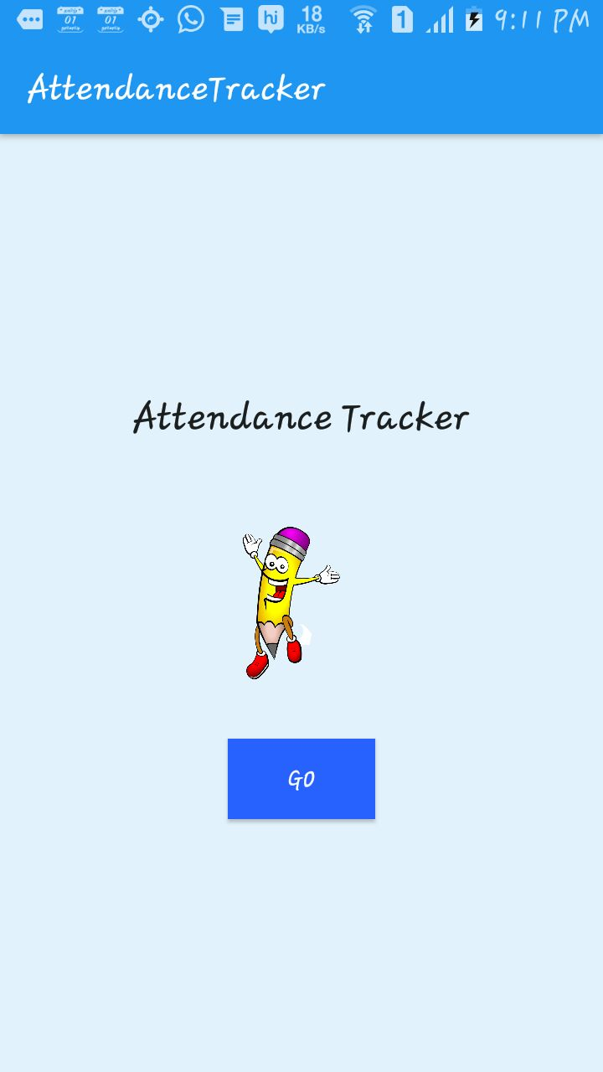

Figure 8.1 Launching the attendance tracker

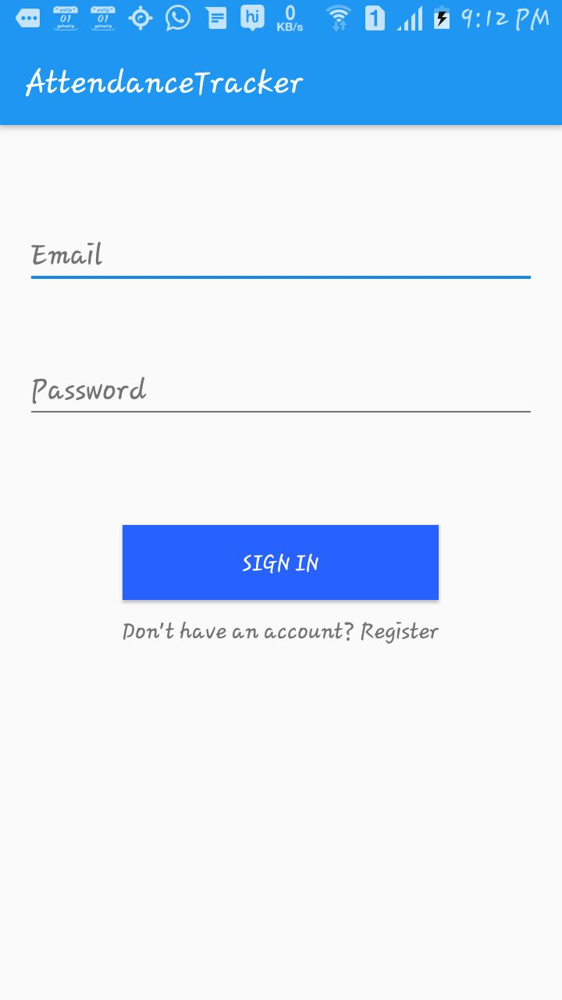

**Figure 8.2 Creating Login Page**

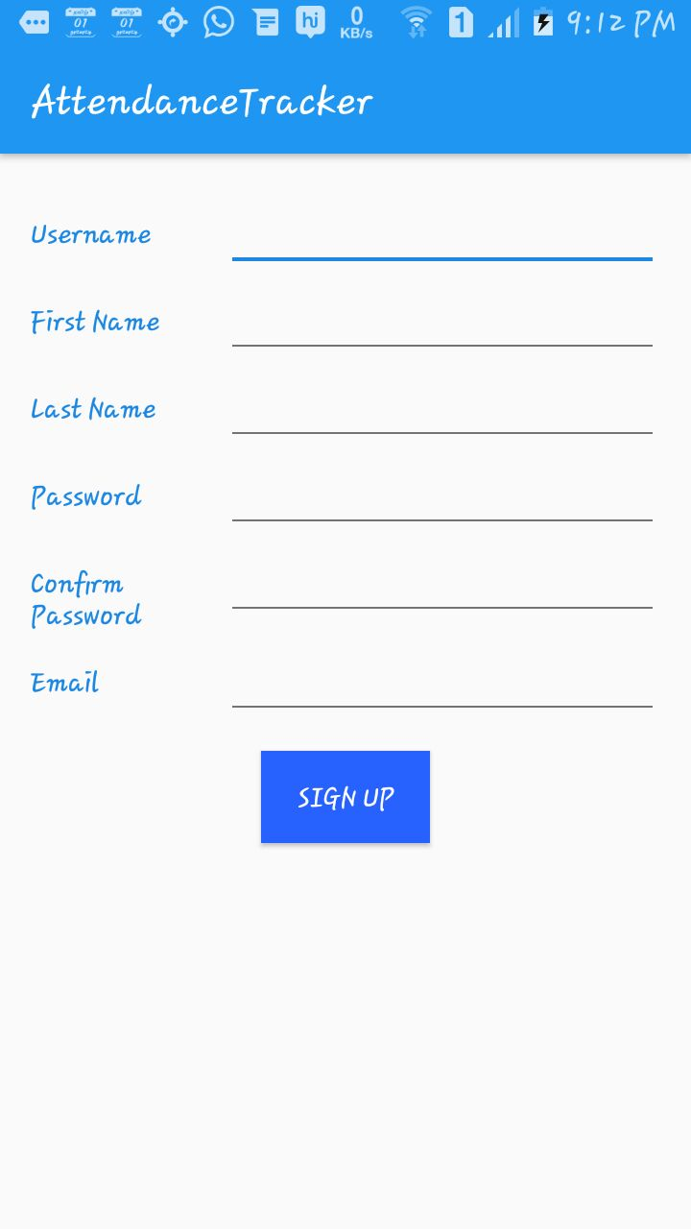

**Figure 8.3 Creating Registration Page**

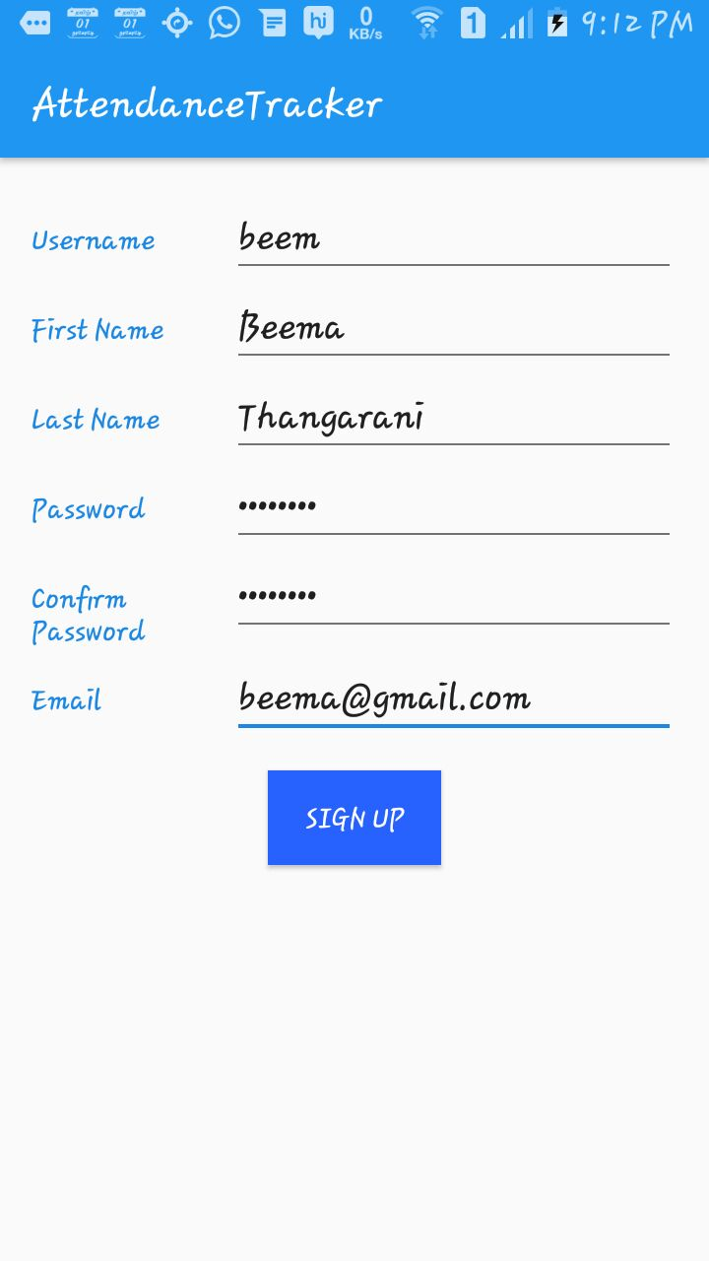

**Figure 8.4 New User Registration**

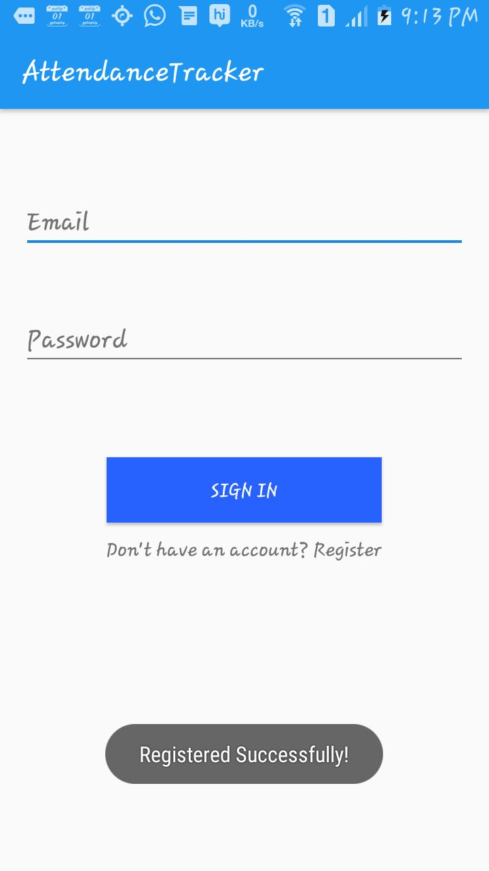

**Figure 8.5 Successful Registration**

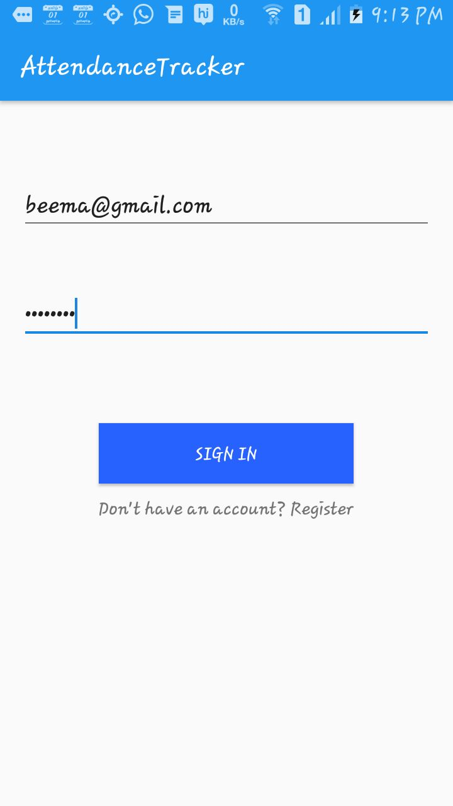

**Figure 8.6 Signing In Page**

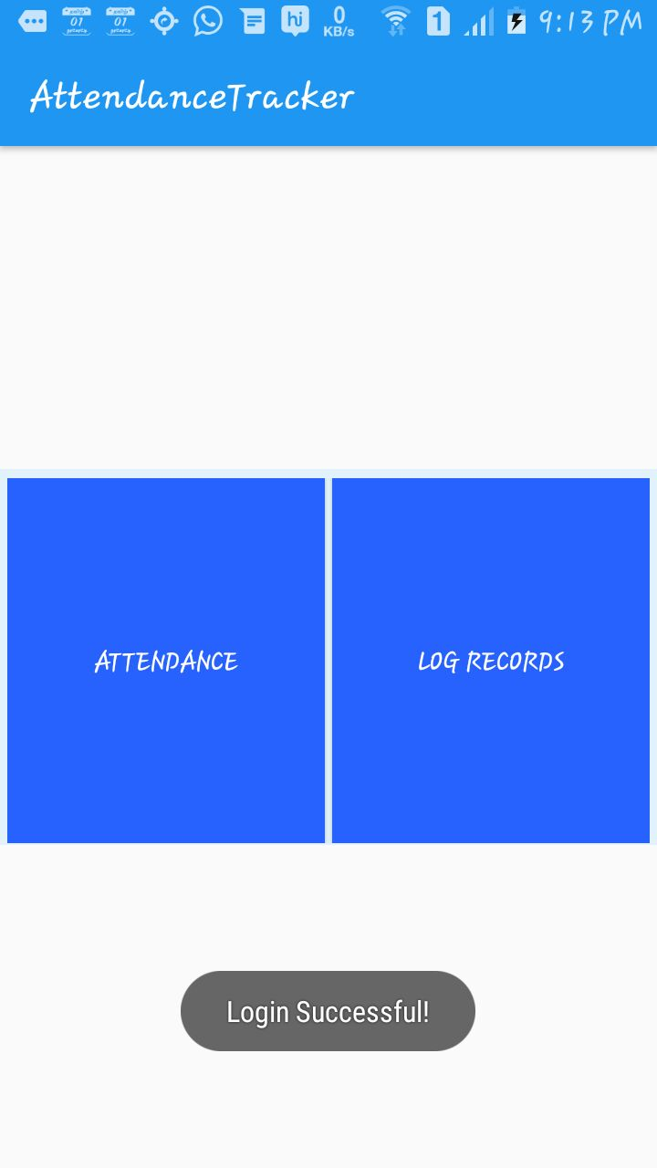

**Figure8.7 Home Page**

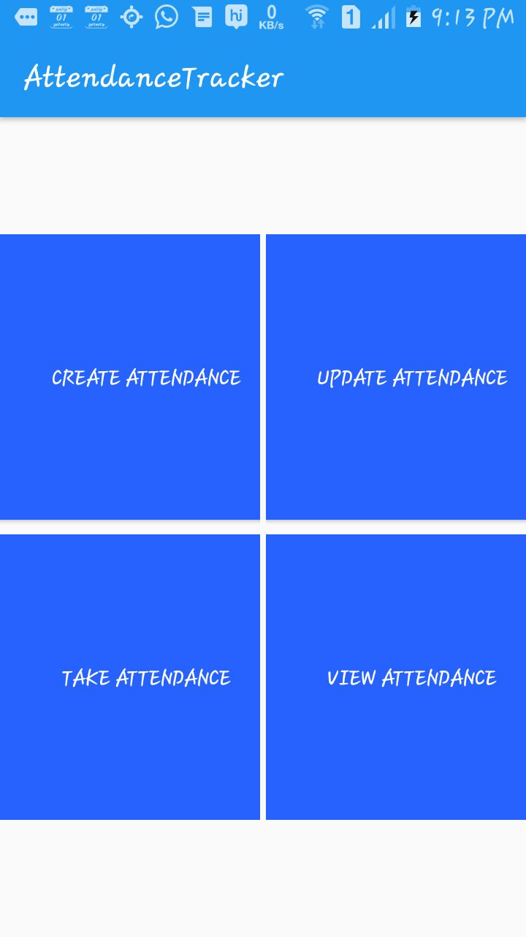

**Figure 8.8 Attendance Activities**

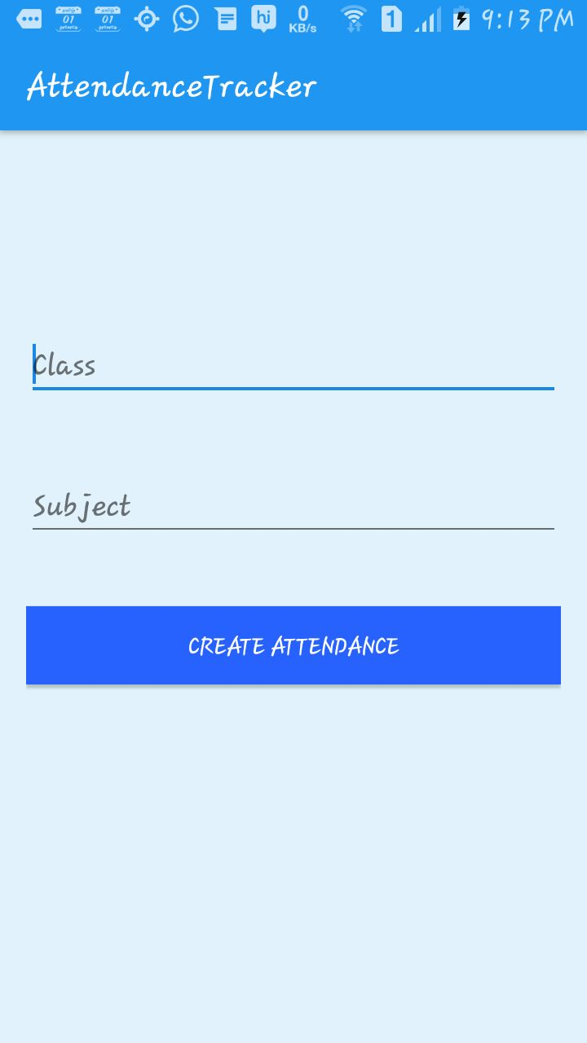

**Figure 8.9 Create Attendance**

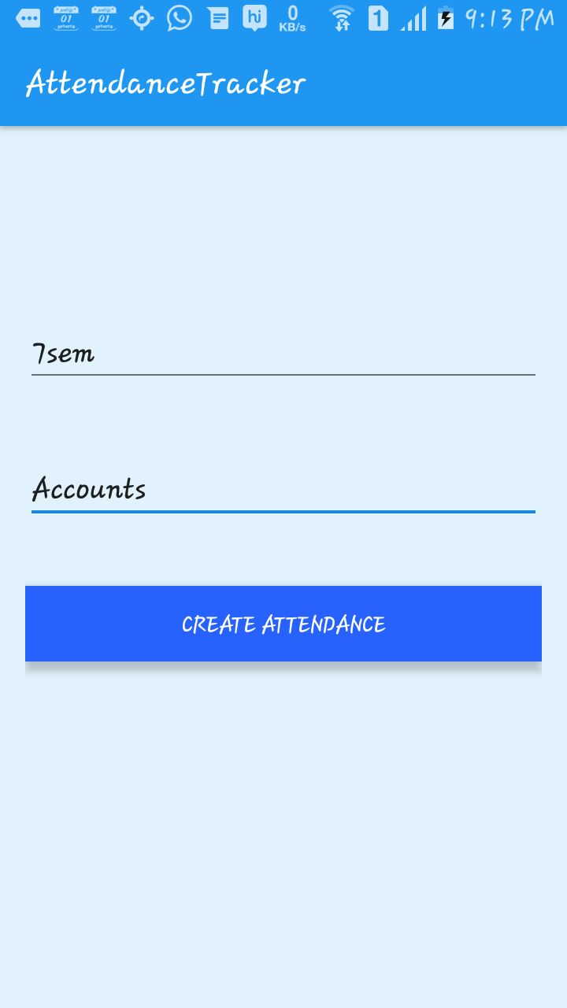

**Figure 8.10 Entering the Subject Details**

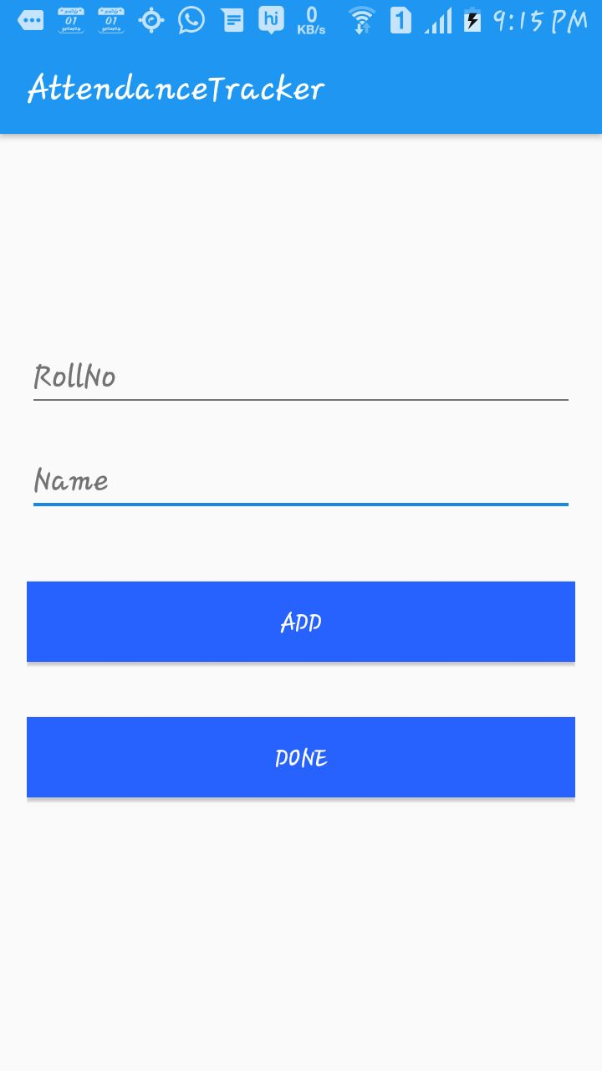

**Figure 8.11 Creating Members**

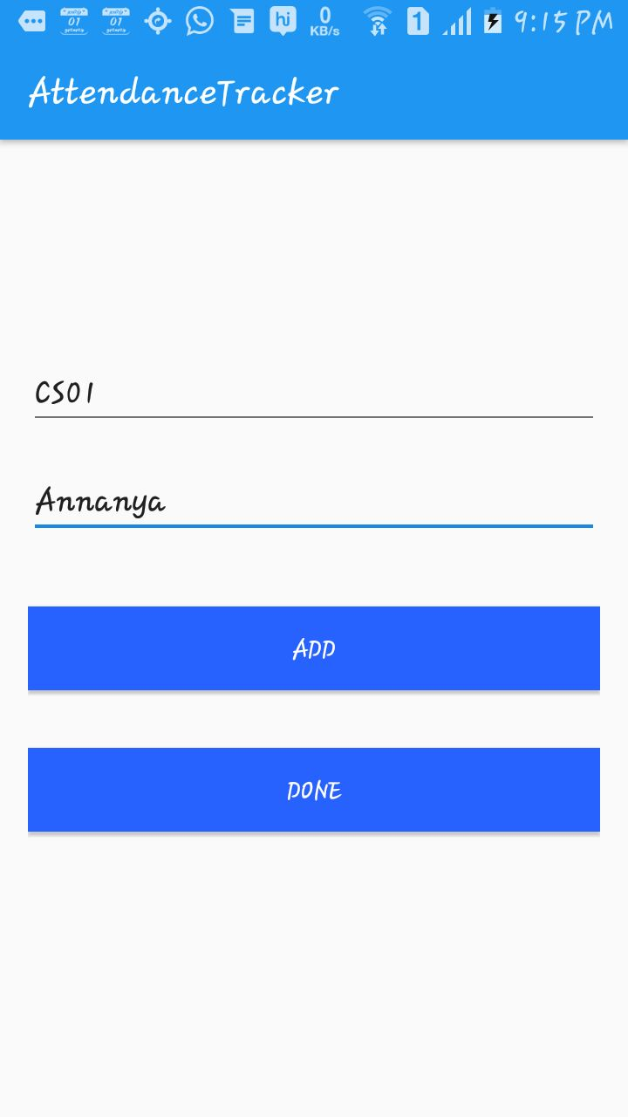

**Figure 8.12 Entering Details of Members**

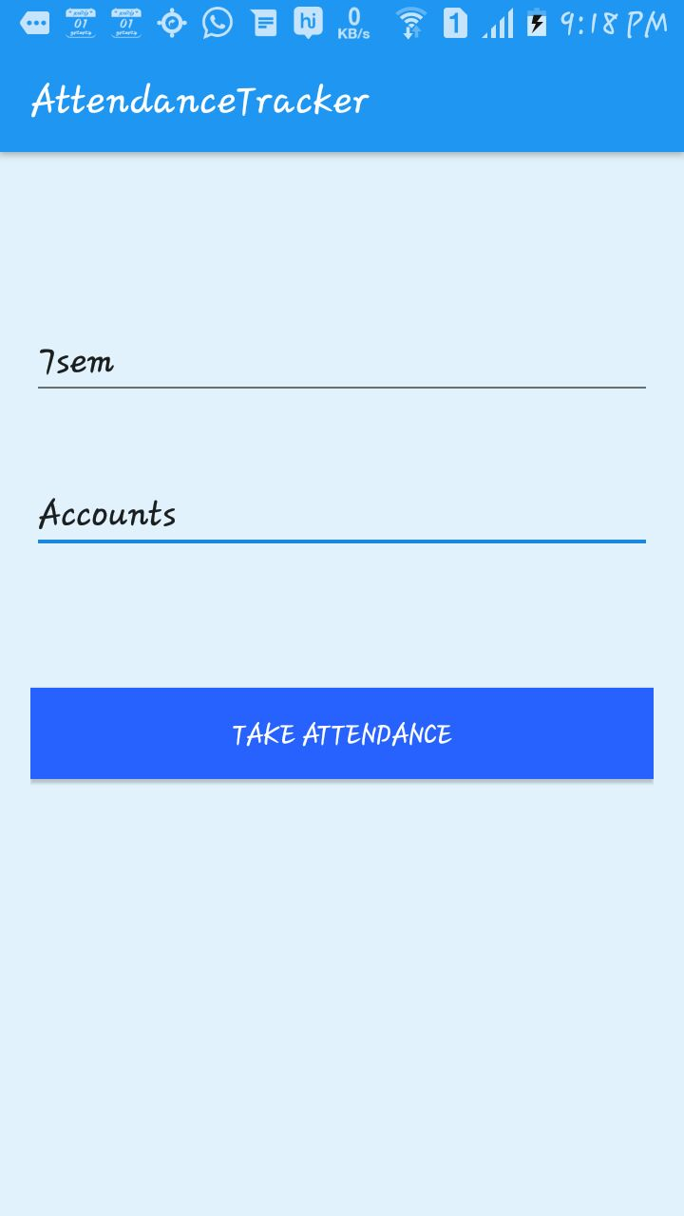

**Figure 8.13 Take Attendance Page**

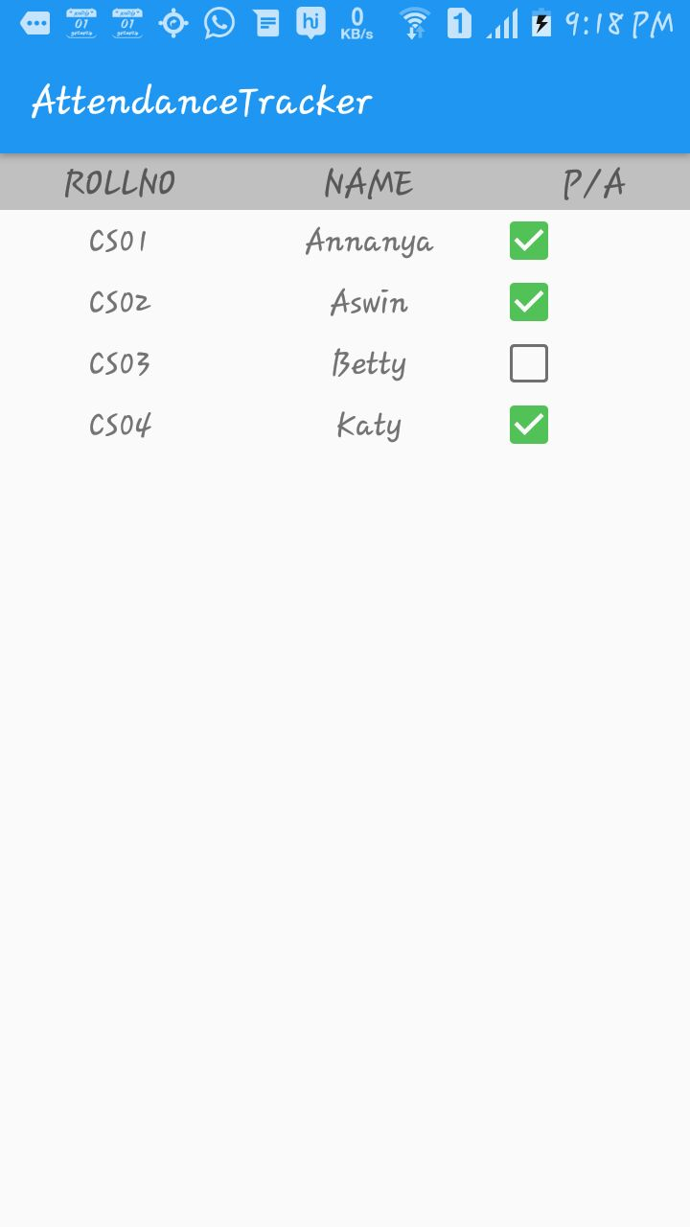

**Figure 8.14 Attendance List**

**Chapter 9**

**Conclusion and Future Work**

An Android based mobile application for Attendance Monitoring is presented. The application offers reliability, time savings and easy control. It can be used as a base for creating similar applications for tracking attendance colleges and in offices or any workplace.

In this paper, we proposed a new system for monitoring attendance of the students using android platform. The results showed improvements in accuracy as compared to using user-based paper-based approach. Moreover the proposed technique provides an easy way for generating reports.

We can add extra technologies like face recognition using image processing , so that attendance get updated automatically.

**Chapter 10**

**References**

[1] K. Akhila, a Novel Approach of Mobile Based Student Attendance Tracking System Using Android Application, International Journal of Engineering Research & Technology (IJERT) Vol. 2 Issue 4, April - 2013 ISSN: 2278-0181

[2] Djoni Haryadi Setiabudi, Lady Joanne Tatyana, Winsen. “Mobile Learning Application Based on Hybrid Mobile Application Technology Running on Android Smartphone and Blackberry”IEEE International Conference, 1 - 5, 2013

[3] MHsuan Che Yang, Wen-YingWang.“Facilitating Academic Service-Learning with Android-based Applications and Ubiquitous Computing Environment” 978-0-7695-4493-9/11 26.00 2011IEEEDOI10.1109 U-MEDIA.2011.29.

[4]Christopher Dong, Xing Liu.,“Development of Android application of Language studies” 2013 International conference on Electronic engineering and computer Science. 2212-6678 2013.